First Light Lite
December 5, 2022
Jim Lynch – Editor
Message from the CCAS President
Please forgive this somewhat late newsletter. I also work as a journal editor, and that job has demanded a lot of time over the last two weeks! But, better late than never – I hope…
Due to being late, and First Thursday occurring on the 1st of December, we’ve already had our monthly talk (a great one), so I have two recent talks to report on here. We’ve also had one lecture/star party event at Upper Cape Tech, and one more planned soon. In keeping with past newsletters, let me start with those first.
Adult Education Program Star Parties at Upper Cape Tech
We are planning to have (initially) two “talk plus star party” events at Upper Cape Tech on November 16th and December 14th. The poster for these is found below. As it says, it is limited enrollment, so sign up early if you’re interested! And for our technically active club members, please let me know if you can work at the December 14th star party via email. We had a very good club turnout for the first event, and I’m hoping that will repeated at the next one!
The first event, on November 16th, went quite well except for the absence of one important ingredient – stars. As is not unusual on the Cape, we were clouded out of the star party component, and so have contacted the attendees that they will be issued a rain check for a star party for them at Werner Schmidt Observatory, either in late January or February. (If the December star party component is also weathered out, we will give the same rain check to those attendees.)
The initial November 16th lecture part was devoted to an overview of amateur astronomy, and we had an interested group listening in. Many in the audience owned small scopes, or good binoculars, and were looking to get more active in observing the night sky. Hopefully, the tips and links provided in the PowerPoint presentation were useful, and the presentation was also emailed to the group.
Since the stars were not to be seen that night, we devoted the second part of the evening to showing the attendees how to work actual amateur scopes (a Dobsonian and a German Equatorial Mount with a refractor) that we had along for the star party. This “hands on” look seemed to be appreciated by the attendees.
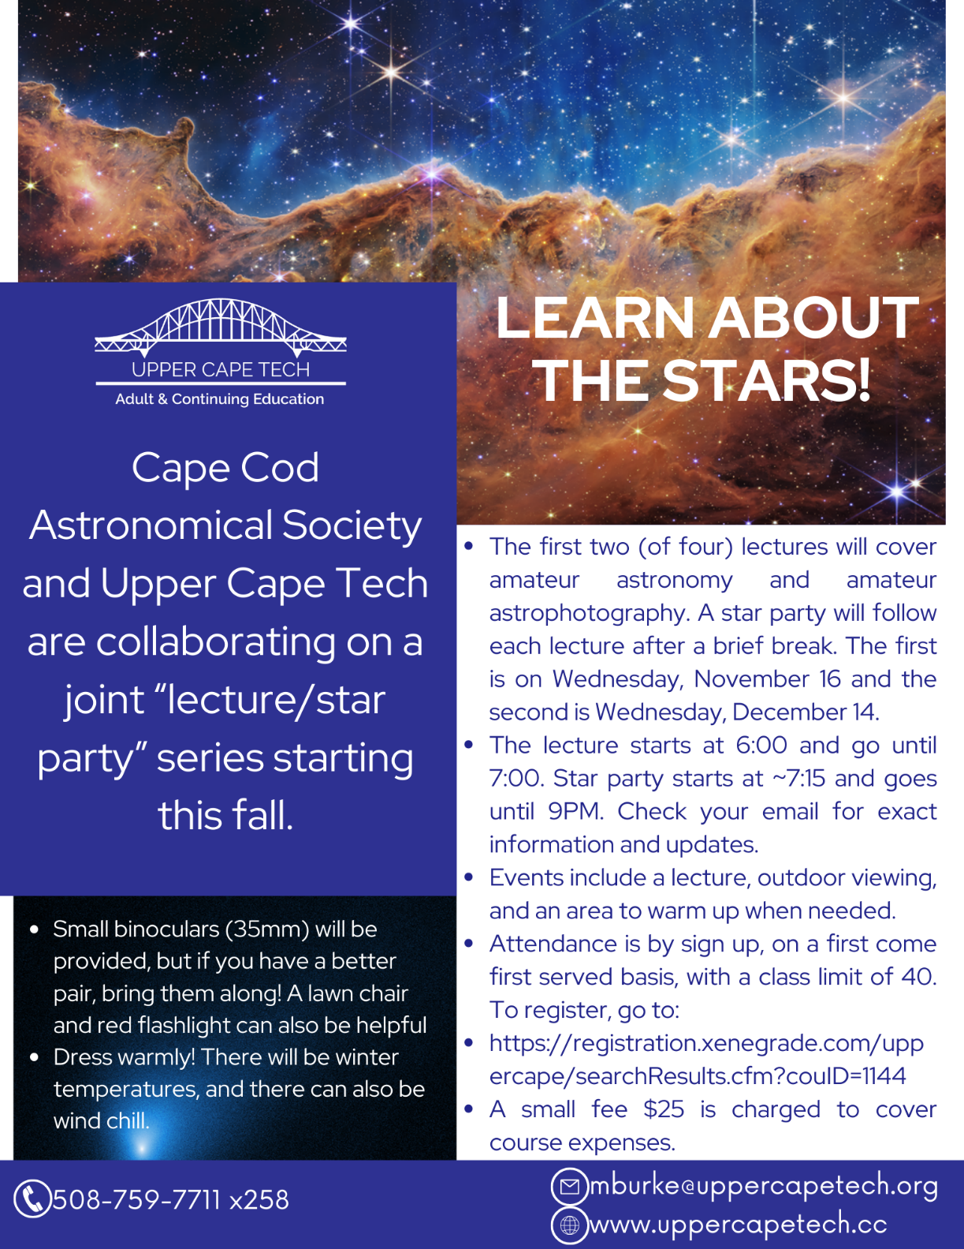
Member Training (a repeat of last month, but still relevant!)
We still need a few more people to get familiar with “things amateur astronomical.” As mentioned in a previous newsletter, amateur equipment is made to be user friendly, and learning the night sky is only a matter of a night or two’s observing. Charlie Burke and I have started work/training sessions both at WSO and in Falmouth. Using solar scopes, go-to mounts, and basic photography will be major parts of the sessions, which will also be done in daytime to make things easier for members.
We had our first session on November 28th at WSO, focusing on go-to mounts and our solar scopes. We made progress, and also found out about items that need some more attention. I think it would be fair to call it a successful afternoon!
We will soon be planning more such sessions, though the Holiday Season may slow down our rate a little in the immediate future. Dates will be announced via email.

Last Month’s Speaker
November 3rd
Dr. Martin Elvis, Harvard Smithsonian Center for Astrophysics
“Asteroids: How love, fear, and greed will determine our future in space.”
This is an easy talk to write about, in that there exists both a YouTube version of the talk and a book, and they both are excellent! The YouTube link is below. From Martin’s email to me:

“You can point anyone who's interested to a 1-year-old version of the talk,
as given to the Edinburgh (Scotland) Astronomy Society:
ASTEROIDS: How Love, Fear, and Greed will Determine our Future in Space - YouTube “

As to the book, here is the cover:

It is $25 (hard cover) on Amazon and is a great read. And it is NOT a standard astronomy text! Rather, it uses the concepts of love, fear and greed to talk about asteroids (particularly near-earth asteroids) from very human motivations. Love is (spoiler alert) the love of knowledge, and so Dr. Elvis first discusses asteroids from the points of view of what we know about them and what we hope to learn using new technologies. The discussion is in very clear, understandable language, and you will learn a lot about asteroids without having to be a professional physicist, geologist, chemist, astronomer, or rocket scientist. The “Fear” comes in from what these Solar System neighbors can do if/when they visit Earth. This is a standard astronomy topic, but again, the book makes numerous interesting points that you might not see elsewhere. The really different part of the book is where it discusses the commercial possibilities of asteroids, and how we might exploit them. Very few, if any, astronomy books have a business-oriented section in them, but “Asteroids” does – appropriately filed under “Greed.” Whether you might like it or not, the business aspect of asteroids promises to be an important part of our exploration of the Solar System and will probably provide crucial resources that will allow us to do so. It will also spur technological advancement, as a huge secondary benefit. There is much more detail to describe in the book, but perhaps I’ll just recommend that you buy it (after you watch the YouTube video above) and see what I mean!

December 1st
Dr. Nathan Whitehorn, Michigan State University\
Title: Neutrino Astronomy
Abstract: The Earth is constantly bombarded by high-energy particles. At low
energies, these particles are mostly from the Sun, producing the aurora
and other familiar features of the sky. But some have energies that
reach far beyond the Sun's capability to accelerate particles, extending
far beyond even the reach of supernovae and to more than 10 million
times the energies available even from the highest-energy man-made
particle accelerators. These must come from the most violent processes
in the universe, but which ones and where remains almost completely
unknown. This talk will discuss an approach to find and understand these
sources using neutrinos, an electrically neutral cousin of the electron.
This requires enormous natural detectors located in the deep ocean or
the polar icecaps, which have yielded the first glimpses of the distant,
high-energy universe over the last decade -- and it has become
increasingly apparent that that glimpse is telling us something
unexpected: that the sources of these high-energy particles are not what
we thought they were and that the neutrino sky is not the one that we
are used to. In this talk, I will describe the current state of our
knowledge of the neutrino universe, how we got there, and the next steps
to resolve this puzzle.
Precis: Cosmic rays, i.e. particles from space which can have energies of up to 100 million times those created in the Large Hadron Collider, have been a mystery since their discovery in 1912, one hundred ten years ago. Why so long? The prime reason is that they are not so easy to observe and track back to their sources. Cosmic ray protons are curved by magnetic fields in space, losing their directional information en route to us. And when the particles hit Earth’s atmosphere, they produce messy showers of secondary particles, which contain useful information, but take work to decipher. So, what do we do? One answer is to look at neutrinos, which are almost massless elementary particles that can penetrate matter readily and seem like an ideal probe for cosmic rays, as they come to us the most directly. We see neutrinos from nuclear reactors, the Sun, cosmic rays hitting the atmosphere, and also from unknown sources. As the business of science is to explore unknown phenomena, tracking neutrinos has become a research priority. Some suspects for the high energy neutrinos are supermassive black holes, gamma ray bursts, and galaxy clusters. However, based on a first map of the high energy sky, these can only account for a fraction of the observed events. Moreover, the high energy sky does not look at all like the optical sky, and so there is something else going on. The story is still in the early stages of telling, and a big part of it will be deploying new detectors, and indeed the topic of detectors was a large part of the talk. For any oceanographers reading this, the NEPTUNE cabled underwater observatory will host one of the most advanced neutrino sensor arrays ever built, an idea that was proposed a quarter of a century ago but didn’t have the technical support or equivalent funding that our modern oceanographic observatory structure affords. Stay tuned!

Next Month’s Speaker - TBD
Directions to Dennis Yarmouth HS and Schmidt Observatory

For information on the location of our Dome behind Dennis-Yarmouth High School, click on the purple button "Old Website" and once there, click on "Meeting Location" viewing the two maps that are there: external for the Dome, and internal to locate the high school library where meetings are held.

For meetings, drive in the south entrance road and go around behind the main building. Park in the lot about halfway down the building and go in the back door and turn down the hall to your left to find the library.

For Star Parties at the Dome, drive in the north entrance road all the way past the north side of the main high school building, through a gate, and on to park near our Dome.
H&K directions
CCAS hosts a dinner gathering for the speaker (if available), members and friends on meeting nights (just before the meeting) at the South Yarmouth Hearth & Kettle restaurant at 5:45pm; (the meetings begin at 7:30 at D-Y.) Please join the group to dine and talk about all things interesting, especially astronomy, before our meeting. The H&K is at 1196 Rt 28, South Yarmouth, about a half mile west of the Station Avenue/Main Street intersection with Rt 28 (stop light). NOTE: Since Covid, we have a mix of fully remote and hybrid in-person+ remote meetings. Check the newsletter and/or website to see what the format is each month! There are no dinners when the meeting is fully remote.

