First Light Lite
March 1, 2021
Jim Lynch – Editor
Message from the CCAS President
Looking out the back door this month, there is no snow, just cold and rain. But, there have been weather windows, and so good viewing conditions this time of year. I hope everyone has gotten a chance to look outside!
As previously discussed, CCAS is doing well enough in “virtual land” with our First Thursday meetings and talks, and we some exciting speakers lined up for the next few months! This month we have Dr. Jim Gates and Ms. Cathie Pelletier speaking about their book “Proving Einstein Right,” as has been mentioned before. This will be on Zoom, as we are switching from GoToMeeting to allow better access for some of our student listeners.
As to star parties, the vaccination program, even if a bit iffy in MA, is moving along, and we’re working on possibilities to start back with some public programs when we get permissions from the sites we’d like to use. In the meantime, George Silvis’ occasional online sessions are well worth tuning in to, and indeed George will be giving a talk at the club portion of the April meeting (after the Guest Speaker) to show some beautiful light curves from exoplanet transits that he obtained just a few nights ago at one of his invited sessions. (Again, if you want an invitation, please just email me and I’ll put you in touch with George.) I’ll show some “teaser” results below.
And, as mentioned in a previous newsletter, we are not the only club/organization that has virtual star parties during the pandemic. Maria Mitchell Observatory, on Nantucket, has a bigger program (they are a complete nature center), and you can look in on one of their parties this month. Just look at their website for details on how to sign up.

The emphasis of today’s newsletter will again be mostly on the future, and what we are doing to plan for it while waiting for the pandemic to abate. In-person activities, when resumed, will be a bit different from past practice, and we should use this remaining “down time” to prepare for things.
Committees
On February 5th, at 7:00 PM Eastern, we had a 1 ½ hour long kickoff meeting of three newly formed CCAS committees: 1) Programs/Content, 2) Membership/Outreach, and 3) Communications. On February 16th, at the same time in the evening, we had the first regular, monthly meeting of those committees, along with a newly formed “Invited Speakers” committee.
We now have a small core group for each committee, but (again) we really, really could use additional members. This is a once-a-month, half hour Zoom session commitment, though with a bit of interesting homework also involved. We sincerely need people to sign on and help with these to get our program(s) back in good order. To do this, just drop me an email at jlynch@whoi.edu saying “I’m interested” or, if you’re logged into our meetings, stay around for the club meeting portion and tell me in (virtual) person. I’ll send you a link to the next CCAS committees meeting, as well as minutes of the last meeting and an upcoming meeting agenda, as soon as I get an expression of interest!
Upcoming Meeting Talks
The agenda for talks is again the first item to discuss. The roster has fleshed out since our last announcement, and I think we have some exciting talks to offer to CCAS, the student communities we reach, and even some other astronomy Societies that we have friendly relations with.

The speaker for March is Dr. Jim Gates, (see link https://www.aps.org/about/governance/leadership/board/president.cfm), who is the current President of the American Physical Society, and is also well known to the public for his Nova and other media appearances. Jim agreed last spring to give us a rain check for the talk that was cancelled on March 16th, 2019. Both he and his co-author, well known writer Ms. Cathie Pelletier, https://en.wikipedia.org/wiki/Cathie_Pelletier ,will come (virtually) to talk about their book “Proving Einstein Right” to CCAS and the Cape area schools. This talk will be our “First Thursday” talk at 7:00 PM Eastern on March 4th.
Recently, University of Washington astronomer Dr. Emily Levesque also agreed to speak to us, https://www.emlevesque.com/ and will be giving our April 1st talk on her book “The Last Stargazers.” Emily having been an MIT undergraduate, and a lover of (and participant in) the pranks (“hacks”) MIT undergrads are famous for (read “Nightwork” by MIT press if you are interested) has indicated that, in addition to a great talk, there might be an online hack (of the fun variety) for April Fool’s Day. Stay tuned!
In either May or June (TBD), Dr. Daniel Davis, co-author with Brother Guy Consolmagno of “Turn Left at Orion” will speak to us about some amateur astronomy experiments that can easily be done by students and/or beginning amateur astronomers. Information about Dr. Davis can be found at: https://www.stonybrook.edu/commcms/geosciences/people/_faculty/davis.php
Also, Dr. Alyssa Goodman, whose work on the "Radcliffe Wave" discovery has been prominent in the news this last year, has also agreed to talk to CCAS this summer, hopefully live if /when meeting restrictions are lifted.
And Dr. Jim Head, who just gave a great talk to us on the Chinese space program, will talk about Mars exploration (a very hot topic of late) in the fall.
We also have 1-2 other possibilities, but are waiting to solidify arrangements.
One unique thing that will happen this winter/spring is that for each of the four talks that we have scheduled, we will be giving away the author’s books to the Cape HS students that attend (and Moon maps for Dr. Head’s talk.) This comes at some cost to the CCAS, but is also supported by some donations to CCAS. These hopefully will be good incentives to the students to both listen to some great talks, and also to read some very interesting STEM related material. The logistics of how this will work has been arranged with the area HS teachers.

Welcome to Other Astronomy Clubs
One rather nice thing that has happened during the pandemic is that we have been sharing information with other astronomy clubs and organizations about their upcoming talks and ours. I will generally post this information in separate emails, as the schedule dictates. Again, our welcome to the members of the Phoenix Astronomical Society and the South Shore Astronomical Society to our coming talks!

In Memoriam Jim Carlson
Founding CCAS member Jim Carlson passed away last week. One of our stalwarts, Jim was at various times president, secretary, First Light editor, CCAF trustee, observatory director, etc. He was also one of two CCAS life members. He was the one who, in 2004, did the work to demonstrate the research capabilities of Werner Schmidt Observatory so as to obtain official recognition and designation as observatory I06. In 2005, he took the lead when we verified the existence of an exoplanet. In recent years, we saw Jim mostly at the observatory helping with the telescopes and star parties.

“Backyard Astronomy” projects update.
Before mentioning the “DYI mini projects” I’ve pursued, let me show a very nice project by George Silvis, using his (rather sophisticated) home observatory telescope and software. This is “backyard astronomy” for the very serious and skilled amateur!
George is a senior member of AAVSO (American Association of Variable Star Observers), which studies (you guessed it) the variability of stars. Its members use their home telescopes (often quite advanced ones, like George’s) to collect a data base on these objects.
One class of phenomena that AAVSO tracks is exoplanet transits across the face of stars, which affects their light intensity curves in ways which tell the observer about these planets. George obtained beautiful light curves for two exoplanet transits on February 25th (to which his list was invited), and as I will show one below.

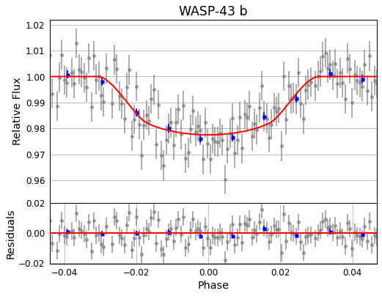
This is really nice data, and a bit past a DIY project, but it also shows what you can do with what is essentially amateur gear! George will be giving a talk about this in the club portion of our April meeting, and I hope you can listen in!
As to the three “DIY mini-projects” I’ve chatted up, I’ve only received one response about the explanation of the lunar crater size distribution I showed last month (shown again below). So, I’ll give things another month, hoping that they’ll be some competition! The question is repeated below.

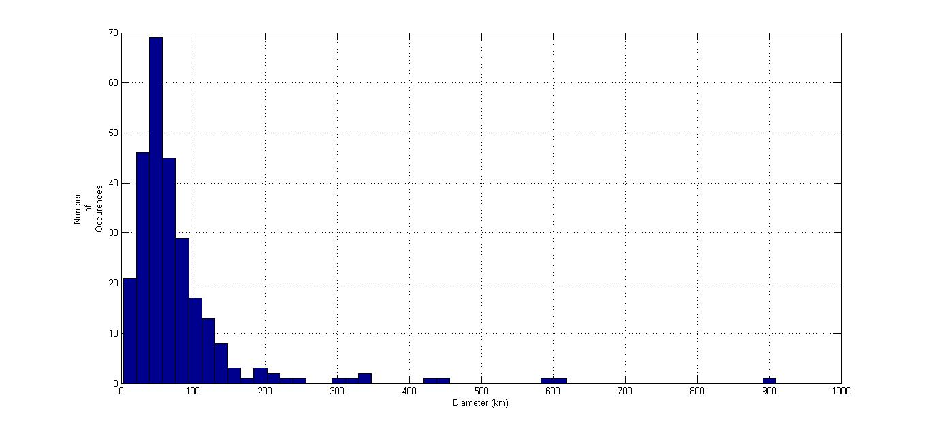
“With apologies that the labels are a bit small, you can see that the craters, which range in diameter from 3 kilometers to 900 km, have a peak at around 50 km, and then fall off drastically past there. For those who heard Tony Stark’s talk “Astronomy Can Save Your Life,” you’ll recognize that the falloff of the number of craters as one goes to larger and larger sizes is expected from the size distribution of the asteroids that pummel the Earth and Moon, and thus cause the craters. However, why do you see the drop off in number below 50 km?! The best answer wins a Moon map next month!”
The “sunrise position” project is coming nicely, with my second year of data underway. The cross comparison with last year’s data isn’t bad at all, and is giving me some insight into how good/bad my crude observing system (a $1.25 protractor) is. I’m throwing in a few more measurements to make the story more interesting, and will try to show these soon.
As to the “sky brightness/light pollution” project, I did get a bit more sensitive sensor, but it has not gotten much exercise this last month. Again, I’d like to take a few more measurements before showing results.

Last month’s speaker

February 5th, 2021

Dr. James Head, Brown University

ABSTRACT: China has embarked on an ambitious and fast-paced robotic lunar and planetary exploration program, including the first lander and rover on the farside of the Moon, lunar sample return missions (Chang’e 5 being recently very successful), rovers on the surface of Mars, and missions to many other destinations in the Solar System. Plans also call for Chinese astronauts to explore the Moon by the end of the decade. What is the scope, significance and direction of the Chinese space program and how does it differ from that of the US and other countries? We will put particular emphasis on the recent Chang'e 4 Lunar Farside robotic rover mission, the Change'e 5 lunar sample return mission, and Tianwen-1, the Mars rover mission in transit to Mars.
PRECIS: Jim provided the following addendum just before his talk, and for those who might have missed it in last month’s FLL, here it is again.
LATE ARRIVING ADDENDUM!

You could send out the following link to this podcast I recently did for the Watson Institute on the Chinese Space Program. Students and members might find it of interest.

China’s Mission to the Moon, and the New Politics of Space Exploration
Between the presidential election, spikes in the coronavirus pandemic, and the beginning of mass vaccination, you might have missed this other world-historical event: China landed on the moon. On this episode, Watson’s Director Ed Steinfeld talks about China’s lunar mission with Watson Faculty Fellow Jim Head. Jim is a Professor of Geological Sciences at Brown, and a leading expert on interplanetary exploration.
Returning to the talk Jim gave, it was not just about the technical details of space exploration! Rather, it started off with some thoughts about the sociological implications of space exploration at the international level. The role of national space programs, our cultural stereotypes and biases, and what are the realities were the first topics discussed. The politics of space programs came next, with policy, planning and national leadership being the topics of interest. China’s long-term view of things, and their “Silk Road to Space” was an interesting contrast to the USA’s vibrant, but in some ways more short-term approach.

A discussion of the USA’s space program and NASA came next, including a rather detailed look at NASA’s organizational structure, something that the US general public doesn’t really know much about. One slide that it was obvious that Jim was very excited about was the on the “Era of collaboration between astronomers and planetary geoscientists,” which had a graphic showing the thousands of exoplanets that have been discovered to date. (See George Silvis’ graph above!) A picture of James Webb and the incipient Webb telescope was also prominent in the discussion of the US space program’s future.

The next big topic was the Chinese space program. The organizational chart for China’s space efforts received a fair amount of attention, as it is a bit complicated. But Jim was quite familiar with its intricacies, as someone who had collaborated with China for a number of years.

For instance, China’s astronauts are all from the People’s Liberation Army, not too dissimilar to how our astronaut corps started out, though we now are moving towards civilians in space. The observatory system of China is under the auspices of the Chinese Academy of Sciences (Academia Sinica), and consists of upper-level researchers, with no undergraduate presence. The Academy has a roadmap for Chinese science, applications and technology that extends to 2050, much longer than the usual ten-year US planning horizon. Prominently displayed were their space science goals, and the new “Sky/Heavens Eye” spherical radio telescope, which is along the same design lines as Arecibo, but is 500m in diameter, as opposed to 305 for the (now defunct) Arecibo system.

The Ministry of Education came next, which is in charge of China’s university system. This pipeline for China’s future scientists is very active, as anyone who has dealt with China academically can attest. STEM enrollments have been increased enormously in recent years.

Next came the commercial sector (China Aerospace Science and Technology Corporation) that produces launch vehicles and other space hardware. This consists of literally hundreds of companies, many of them commercial and on the stock market.

The Ministry of Industry and Information Technology was next, and it is under this agency that the China National Space Administration resides. This is the agency that administers the Chinese Lunar Exploration Program (CLEP) and its engineering efforts. The Chang’-E 1-9 lunar efforts (with the most recent being the highly successful Chang’-E – 5 lunar mission which brought a lunar sample back to Earth) are ongoing, and their end goal is a lunar village! Jim gave a rather nicely detailed view of this program’s various missions, from orbiters to landers. The Chang’-E 5 mission, of course, got the most attention, including an onboard camera view of the landing. The drilling ops, liftoff from the Moon, sample transfer to the orbiter, and the return to Earth were all amazing to see real pictures of.

Next came an overview of China’s planetary exploration program, including a space station, Mars exploration, Jupiter, the Moon, and asteroids. The Tianwen-1 mission (orbiter and rover) is currently orbiting Mars (it entered orbit on February 10th of this year), and the rover is scheduled to land on Mars in May or June. The landing site at Utopia Plantitia is not far from the Jezero crater site that Perseverance just landed at. Jim described the data that both the orbiter and rover would be taking in some detail. It is a lot, and between the US and Chinese vehicles, Mars is becoming a lively place.

As to what the future holds for Mars exploration efforts, we have a great opportunity to find out from Jim next fall, by which time there will be a lot of data in hand. Jim will be giving a talk then, so stay tuned for the next great installment!

