First Light Lite
September, 2019 Edition
Jim Lynch - Editor
August turned out to be a rather decent month for star parties, as we managed to get two out of three in (and would have had all three, if we didn’t miss one call on the weather!) And at the last star party of the month, we actually got to show visitors the new dome scope in action. OK, it took longer than we wished to get the darn thing working, but in the end, it worked well. As seeing is believing, here is a “second light” picture from the scope. (The first image was a nice shot of M13). This is just a two two-minute-long images stacked, and with a small amount of processing. Longer images and more careful processing will give much better images, but even from this quick first attempt, you can see how good an image should be possible!

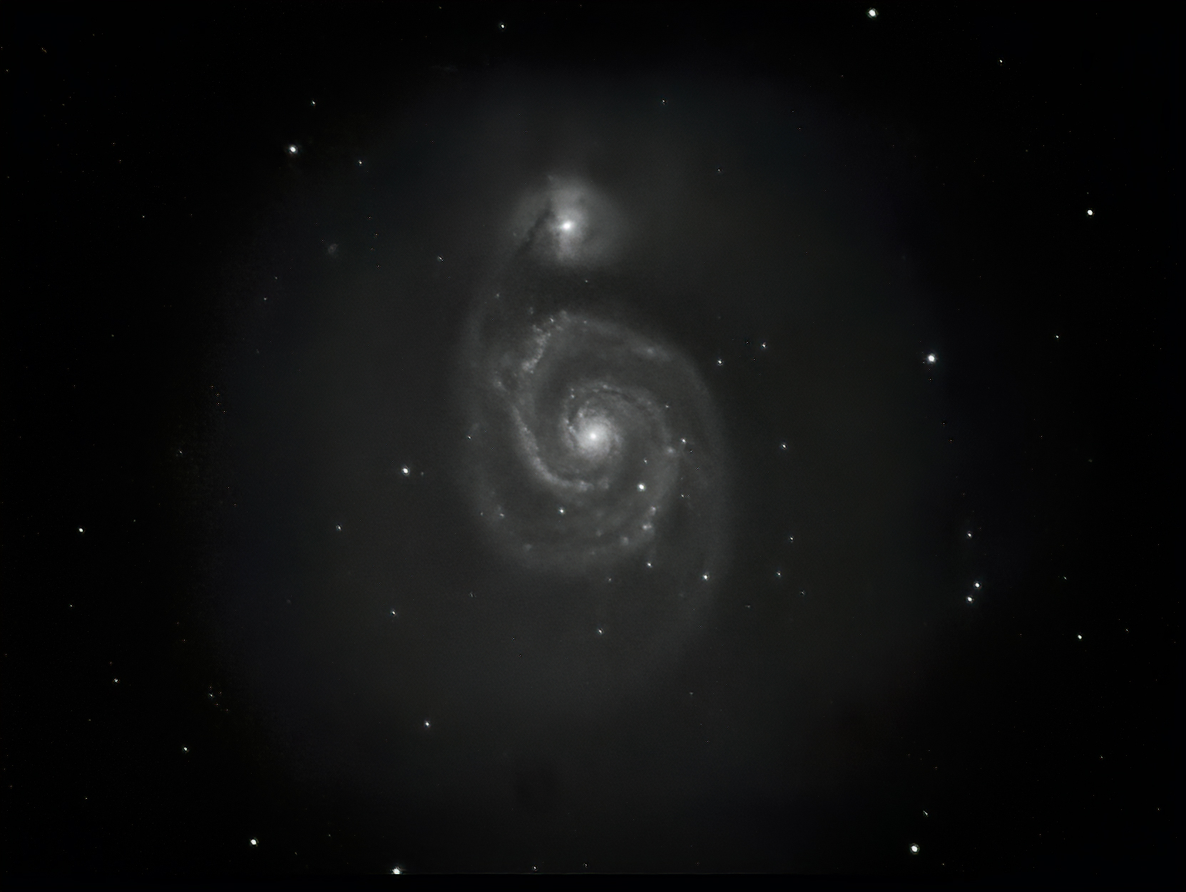

Fig 1. “Second Light” image of M51, the “Whirlpool Galaxy.”

With the dome scope finally operational, our August 29th star party visitors really seemed to enjoy seeing how two minute CCD camera images resulted in computer screen images of M101, the “Cat’s Eye” nebula, M57, and other summer sky favorites. The CCD camera shows very faint details that an eyepiece can’t, and based on how much people liked to see these deep sky objects and learn more about how modern technology (sensitive electronic cameras) works, the camera images will be part of our star party “show” in the future. Of course, we will also have an eyepiece available, which is great for brighter objects (the moon, planets, bright star clusters). Having both these viewing options up and working simultaneously should be done in about a week, but given how things have gone this summer, please don’t hold us to that timeframe exactly!

And, as is usual at our star parties, we will have plenty of outdoor scopes (large and small) and our binocular tour available, so on nights where the weather cooperates, we are very much in business. Again, a big thanks to Charlie Burke et al for their concentrated efforts to get the dome scope up and running!

At the risk of multiply iterated redundancy, let me repeat one important administrative detail. Dues were formally due in July, and are still a low $30 for a family, $15 for college students and part time residents, and free for HS students. Our new treasurer, Dr. Ken Brink, is following up with collecting dues, which we will continue doing over the next few weeks. We have been putting our dues money to very good use for equipment and outreach, and we hope that people will be willing to either start or continue as paying members of CCAS to support these efforts! (Automation of the dome rotation so that members can use the dome scope remotely is one important initiative that we are starting this year.) You can bring checks (made to CCAS) or cash to the meeting, or send checks via snail mail to:

Dennis Yarmouth School District
Maintenance Department
Attn: Werner Schmidt Observatory
296 Station Ave
South Yarmouth, MA 02664
Before getting to our “Upcoming Speakers” part of the newsletter, let me one more time thank the many wonderful guest speakers who have come here, and who have agreed to come here in the future. CCAS has enjoyed a first-rate lecture program throughout the years, with many prominent, working professional astronomers and astrophysicists coming here to give public talks. We are privileged to have them visit, and we hope that they will still want to come here to the Cape in the future, despite our sharks and tornadoes!

Upcoming Speakers
September 5th
Dr. David Wilner
Associate Director
Radio and Geoastronomy Division
Center for Astrophysics | Harvard & Smithsonian
Title: New Eyes on Planet Formation
Abstract: To understand where the Earth comes from, we have to look beyond what's visible to the human eye. Using radio telescopes, we can now "see" directly the raw material for new planets orbiting around young stars and probe the process of planet formation in action. This talk will introduce some basic ideas and open questions about planet formation, from properties of our own Solar System that you can deduce from your own backyard to the latest advances from giant new radio telescopes, in particular new high resolution images from the international Atacama Large Millimeter Array (ALMA) of 66 precision antennas located at 16,500 feet altitude in northern Chile.
October 3rd

Dr. Jim Lynch
President, CCAS
Senior Scientist Emeritus, WHOI

Title: Modern Galaxies – A Brief Overview

As seen in the image above, galaxies are some of the most spectacular and beautiful objects that we can observe, even through non-Hubble amateur telescopes. In this talk, I will try to give an overview of what modern galaxies are like, starting with their morphology (structure) and using our own Milky Way as an initial example. I will then talk a bit about the dynamics (motions) of our beloved barred spiral galaxy and its components. Not to be parochial, I will then move to other types of galaxies, such as ellipticals and irregulars. Finally, I will address assemblages of galaxies, going from the Local Group to the largest scales. If nothing else, this talk should include some really pretty pictures!

November 7th – Dr. Mark Reid, HSCfA

Topic: TBA

December – Mr. Gary Walker, CCAS

Topic TBA
Last Month’s Speaker
August 1st
Dr. Antony Stark, Senior Astronomer
Center for Astrophysics | Harvard & Smithsonian
"Imaging Black Holes"
The last time Tony Stark was here, he described a large project he was involved in to either prove or disprove the theory of inflation, one of the keystones of modern cosmology. Not to be outdone by his last talk, Tony lectured on yet another high-profile project this year, the direct imaging of supermassive black holes. The two main objects imaged, the central black hole (BH) in the Milky Way and the central black hole in M87, are the two largest angular diameter BH’s available, and so were natural choices for the first targets. The effort to build a global array of closely coordinated radio telescopes able to do very long baseline interferometry (VLBI) imaging of these objects spanned many years, and is well documented in the book “Einstein’s Monsters” by Chris Impey. Tony’s talk took the audience through the years that followed Impey’s book, from when the data were taken (2017) to present.
In going through a project like the Event Horizon Telescope (EHT), a logical sequence to follow is to describe the source(s) of interest (the black holes), the receivers (the global array), the data taken, and then the data analysis and results. Tony’s talk pretty much followed this sequence.
To set the stage, Tony very briefly described Special and General Relativity, as BH’s are very much General Relativistic objects. A fun part of the talk was his description of “Penrose Diagrams” for what happens when you fall into a BH. The diagrams show you falling into a rotating (Kerr) BH to reach white holes, parallel universes, wormholes, antiverses, and other mathematically constructible (but probably not physical) objects. The weird, highly distorted optics in the region of a BH were also discussed, though I must disagree with Tony’s assessment in this part of the talk that the movie “Interstellar” was mediocre. Interstellar got 8.6/10 on IMDb and 72% on Rotten Tomatoes, which really isn’t too bad! (And Kip Thorne’s book on “The Science of Interstellar” is a wonderful general public book on exactly the topic being discussed!)
Tony then went on to the equipment, which is one of his fortes. The EHT operates at millimeter wavelengths (1.3 mm), which is the longest wavelength it could use and still resolve the BH with an Earth sized array. This longer wavelength gives smaller phase errors (and phasing is a key issue for VLBI), and is also a sweet spot for energy production by the BH’s. This wavelength, however, was much smaller than had been used before, which necessitated the use of delicate and expensive hydrogen maser atomic frequency standards (clocks) at each of the eight sites to maintain precise phase control. Many other technical advances had to be made throughout the years (see the list of papers below for details) for the EHT to work, but work they did, increasing the sensitivity of the system by a factor of 30 over earlier versions, and delivering an angular resolution of 20-25 μas (micro arc-seconds), good enough to resolve the BH’s shadow.
Tony also briefly described how the EHT’s resolution could be looked at in “the horizontal wavenumber domain,” which was probably a bit arcane for many in the audience. This way of looking at a telescope’s optics is called “Fourier Optics,” and is a powerful tool. Modern optics has progressed enormously far beyond the basic laws of refraction and reflection, and Tony’s slide made me think that perhaps a talk next year on “Optics” would be of interest. Optics has been the bread and butter of astronomy since Galileo, and perhaps deserves a deeper look!
Of data, there was plenty. Each of the eight EHT scopes took ~350 terabytes of data per day, and the objects were each observed over several days during the 2017 “campaign.” The data discs were then moved very carefully to MIT’s Haystack Observatory and the Max Planck Institut fur Radioastronomie. The data analysis was done by four separate sub-groups independently to see if they obtained consistent results. The methods each group used could be somewhat different, but the answer (if correct) should come out the same. And to the delight of all concerned, it did come out the same, producing the famous BH image that we have all seen in the media, newspapers and online.
Given the large amount of effort it took to create such an image, what in fact did it tell us? In this case, I’ll skip a bit over Tony’s head, and quote EHT Board member Paul T.P. Ho. “Once we were sure we had imaged the shadow, we could compare our observations to extensive computer models that include the physics of warped space, superheated matter and strong magnetic fields. Many of the features of the observed image match our theoretical understanding surprisingly well. This makes us confident of the interpretation of our observations, including our estimation of the BH’s mass.”
To conclude, we thank Tony again for coming to talk at CCAS and sharing this topic with us. Tony said he always learns something new when he comes here, and at the risk of triviality, we certainly do too!

For those who would like to see the initial papers published about this famous event, please visit the Event Horizon Telescope website at: https://eventhorizontelescope.org/ . On the site, you will see:
“This research was presented in a series of six papers published today in a special issue of The Astrophysical Journal Letters, along with a Focus Issue that summarizes the published studies. Individual papers can be accessed without any charges via the following links:
- Paper I: The Shadow of the Supermassive Black Hole
- Paper II: Array and Instrumentation
- Paper III: Data processing and Calibration
- Paper IV: Imaging the Central Supermassive Black Hole
- Paper V: Physical Origin of the Asymmetric Ring
- Paper VI: The Shadow and Mass of the Central Black Hole “
As noted, also worth reading are: “Einstein’s Monsters” by Chris Impey and “The Science of Interstellar” by Kip Thorne.

August Meeting Minutes and CCAS Business

The August business meeting was rather brief, with a short update of where we were with the dome scope installation, a repeated call for dues, and an update on the upcoming dome automation project.

Star Parties

After August until mid-June, we will have two regularly scheduled Star Parties each month taking place at 7:30 -10:30pm on the Saturday closest to the date of First Quarter Moon (about 7 days old). This is an increase from our old schedule of one per month in the fall, winter, and spring.

From June through August, we have three regularly scheduled Star Parties each month taking place on Thursdays at 8:30-10:30pm.

When the moon is near its First Quarter, the terminator (the line dividing light from dark) is favorable for viewing sunlight or shadow on the sides of craters. This time is also favorable for observing the dark side of the moon occult (visually cover) stars in the sky as the moon moves in its orbit. Depending upon the calendar, we may also be able to observe planets and other celestial objects.

Here is the schedule for “Star Parties” up to October, 2019; the public is cordially invited!
September 21st, 28th

POSSIBLE CANCELLATIONS for Star Parties: Cancellations will be very rare since we have lots to do "inside" as well as outside. Even if the forecast is "iffy"; the Staff Leader for the night may elect not to cancel in spite of possible clouds. If clouds arrive after staff and guests have convened, a virtual Star Party will usually take place indoors to include overviews of the sky for that night using computer simulations with our big screen TV, videos of interesting sky events recorded previously, demonstrations and/or training on the use of scopes and other equipment, and consultation/discussions on things astronomical, etc.

However, sometimes a solid forecast for overcast or rain or a storm will result in cancellation of a given Star Party. IF IN DOUBT ABOUT THE WEATHER AND THE STATUS OF A STAR PARTY, CALL THE OBSERVATORY AT 508-398-4765 AFTER 7:45 pm. No answer means the event has been cancelled.

Directions to Dennis Yarmouth HS and Schmidt Observatory

For information on the location of our Dome behind Dennis-Yarmouth High School, click on the purple button "Old Website" and once there, click on "Meeting Location" viewing the two maps that are there: external for the Dome, and internal to locate the high school library where meetings are held.

For meetings, drive in the south entrance road and go around behind the main building. Park in the lot about halfway down the building and go in the back door and turn down the hall to your left to find the library.

For Star Parties at the Dome, drive in the north entrance road all the way past the north side of the main high school building, through a gate, and on to park near our Dome.
H&K directions
Please be reminded that Gus Romano or his delegate host a dinner gathering for members and friends each CCAS meeting night (before the meeting) at the South Yarmouth Hearth & Kettle restaurant at 5:45pm; (the meetings begin at 7:30 at D-Y.) The speaker for each meeting is always invited. Please join the group to dine and talk about all things interesting, including astronomy, each month before our meeting. The H&K is at 1196 Rt 28, South Yarmouth, about a half mile west of the Station Avenue/Main Street intersection with Rt 28 (stop light).

