First Light Lite
November 1, 2022
Jim Lynch – Editor
Message from the CCAS President
This fall continues to look like more normal times after two years of Covid. We have had two large public outreach star parties (plus associated lectures), and also our first star party at the Werner Schmidt Observatory (WSO). The latter was held only for the DYHS students and teachers, but we will be returning to star parties at WSO with full public outreach soon. Our star parties so far have shown us what still works well, and also some areas where we need to improve our equipment and skill sets.
Star Parties
I have described our July star party with Joint Base Cape Cod and our September star party at the Cape Cod National Seashore in previous newsletters, so let me just reiterate that they were pretty successful, and that people very much enjoyed them. The new ingredient this month was our return to DYHS and WSO, so let me concentrate on that!
Our Return to DYHS and WSO
Our “home base” for CCAS is the Werner Schmidt Observatory, built twenty years ago on the school grounds of Dennis-Yarmouth HS (DYHS). This was done to facilitate interactions with the Dennis-Yarmouth Regional School District, as well as provide a central Cape location for other activities of the club such as outreach to other schools and the public. It houses not just our “main scope,” a 12 ½” Planewave reflecting telescope located in the dome, but also hordes of smaller scopes, computers and displays, scope gear and attachments. It has been semi-deserted for two years due to Covid, but again is active.
As part of our revival of our direct interaction with DYHS, I gave a talk to the astronomy students taking Ms. Garcia’s classes, and CCAS then held a star party for all of the DYHS faculty and students who were interested. Let me describe both.
Talking to HS students at 7:20 AM is a challenge, not just because of the hour, but because people who are not HS teachers (e.g. myself) have a very hard time gauging the background of the students and also their interest level. Also, the students had requested a talk about black holes, which is probably one of the most theoretically esoteric parts of astrophysics. (I will admit that I personally can only talk about them at an early graduate student level, but no further. But that still leaves a substantial gap.) What to do? Given that these students are intelligent young adults, they deserved the respect of a real, general public lecture, and I did my best to provide one. Both the history and (lay language) basic physics of black holes are fascinating, and I hope the students got something out of it! I also hope we get to have more in-school interaction with the students via both talks and projects, but will admit that we probably need more tutelage from the HS teachers about how best to communicate!
The second part of our CCAS interaction was the DYHS star party, held on October 21st at WSO from 7:30 – 9:00 PM. We used a “best weather day of the week” signup that worked well, and so had decently clear skies that Friday night. Two science teachers came, Ms. Garcia and Ms. Therrien (along with her husband), as well as a dozen students and eight CCAS members. So, we had a reasonably full house!
As with our National Seashore star party, Jupiter and Saturn were the featured fall attractions, followed closely by the Andromeda Galaxy and the Pleiades. But we now also had the dome telescope and its celestial targets as part of the mix, and Observatory Director Charlie Burke happily gave a tour of WSO and the dome to our guests. And that scope also worked well, producing the image of globular cluster M13 below for our guests in less than a minute. The Ring Nebula and a smaller galaxy were also good targets for the main scope. One interesting lesson from the star party was the difference in the “view” that one saw between the binoculars, the small scopes, and the large scope. Binoculars gave the best view of wide-field open clusters like the Pleiades and the Double Cluster in Perseus, whereas the mid-sized scopes gave a better view of Jupiter’s moons and Saturn’s ring. The large scope with a camera could nicely see things like the Ring Nebula, which do not come across easily with eyepiece views. To each instrument their realm!
From a club perspective, we got “back to basics” using the telescope and binocular gear. Some of our newer members got useful experience handling our gear, and we also found out that a few instruments needed some minor repairs. But that is par for the course in amateur astronomy, and part of the fun and challenge.

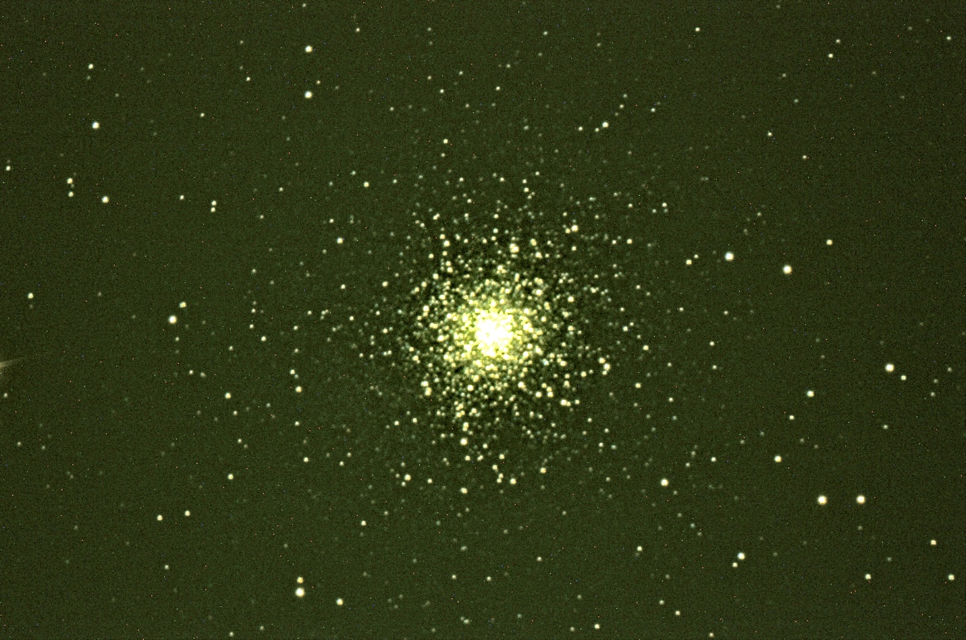
Image of M13 taken at DYHS star party in less than one minute!

Adult Education Program Star Parties at Upper Cape Tech
We are planning to have (initially) two “talk plus star party” events at Upper Cape Tech on November 16th and December 14th. The poster for it is below. As it says, it is limited enrollment, so sign up early if you’re interested!
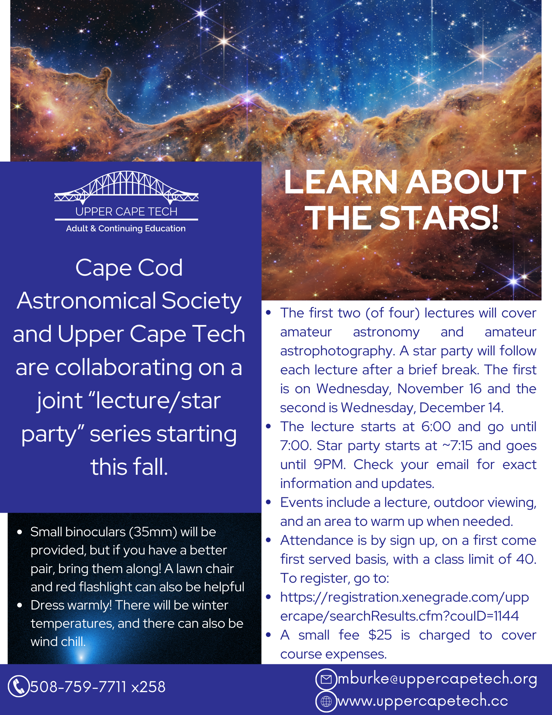
We will need 2-3 members at each of the star parties to work the observational gear (two 8” Dobsonians and a dozen sets of binoculars). If you are interested, please let Jim Lynch know via email at jlynchwhoi@gmail.com !

Member Training (a repeat of last month, but still relevant!)
Over the past few years, we have lost half a dozen club members (due to passing or family matters) who were experienced in using amateur astronomy gear and also were familiar with the Northern Hemisphere night sky. Due to Covid, we haven’t been able to either recruit or train people in these skills over the past two years. But we need to do this, and happily over the past month or two, we’ve had some members step up and become familiar with things. This is part of the enjoyment of amateur astronomy – seeing what we can see in the night sky with decent viewing equipment! But we still need a few more people to get familiar with “things amateur astronomical.” As I said in a previous newsletter, amateur equipment is made to be user friendly, and learning the night sky is only a matter of a night or two’s observing. To help further this essential goal, Charlie Burke and I are planning to have some additional sessions both at WSO and in Falmouth (where many members reside). Using solar scopes, go-to mounts, and basic photography will be major parts of the sessions, which also can be done in daytime to make things easier for members.
A window between 18-23 November for WSO, depending on weather (i.e. we’d meet on whatever day is clear), is currently being considered. Stay tuned for times/dates/details!
School Interactions – Lectures, Projects and Activities
As also mentioned in past newsletters, we have been unavoidably separated from the Cape’s schools for two years, during which there has been a turnover in personnel and even in the directions that the curricula are going. We need to adjust to those changes, and work with the teachers to provide them with material that they can use in this “new era.”
One continuing student interaction will be our “book give away” to any HS students who attend our November CCAS lecture (see below). We can’t pursue this program for all our lectures (due to expense), but we will try to do this for speakers who have also authored popular books which could be of interest to the students. We have a good inventory of books on hand and are hoping there are some interested recipients!

Last Month’s Speaker
Dr. James Lowenthal, Smith College
Topic: Unscrambling the view from Earth of the brightest starburst galaxies"

Abstract: How did large spiral galaxies like the Milky Way form? How about giant elliptical galaxies? One way to address those questions is by looking back in space and time to find dusty extreme starburst galaxies in the early Universe. The brightest ones, it turns out, are mostly gravitationally lensed by intervening massive galaxies and clusters of galaxies. Hubble Space Telescope and ALMA images show us those lensed distant dusty galaxies in great detail, but with distorted views; now our job is to unscramble those images so we can figure out how these monster starburst galaxies fuel their star-forming activity.

Precis: After an interesting pre-lecture discussion of dark skies, and how we are losing them, Dr. Lowenthal went into his main topic – galaxy formation, especially in the early universe. To see the really early universe, one now-common tool is using gravitational lensing by closer (in space and time) large galaxies or galaxy clusters. And having a bright target to begin with helps, which is where the bright new stars of starburst galaxies come in. Unscrambling the distorted images of strongly lensed galaxies is a hard inverse problem, but Dr. Lowenthal and his group have made substantial progress, and indeed have an impressive catalogue of galaxies that they have obtained results for.

Another very interesting part of the talk was the computer movies that Dr. Lowenthal showed of simulated colliding galaxies. Large galaxies seem to be built up by cannibalizing small galaxies, and galaxy collisions are not uncommon at all. The colliding gases and dust of such galaxies is what provides the bursts of star formation we see in starburst galaxies. Indeed, our own (fairly large) Milky Way Galaxy has likely eaten a few small galaxies itself, and though it is an older galaxy, it is still doing so. But predators often become prey themselves, and our galaxy will be colliding with its even larger Local Group neighbor, the Andromeda Galaxy, in 4-5 billion years or so. At that point, there will be a burst of star formation. And eventually, the combination of the two will settle down into a giant elliptical galaxy, a common outcome of large galaxy collisions.

Upcoming Speakers
November 3rd
Dr. Martin Elvis, Harvard Smithsonian Center for Astrophysics
“Asteroids: How love, fear, and greed will determine our future in space.”
In November, Dr. Martin Elvis from Harvard Smithsonian Center for Astrophysics will talk about his recent book, “Asteroids: How love, fear, and greed will determine our future in space.” This book will be distributed to any HS students attending the talk. It will be both live at DYHS and linked via Zoom.
December 1st
Dr. Nathan Whitehorn, Michigan State University
Title TBA on topic of Neutrino Astronomy
In December, we will have Dr. Nathan Whitehorn from Michigan State University speaking to us about Neutrino Astronomy, a topic we haven’t heard about in our talks in the last few years. Remote only via Zoom.

Directions to Dennis Yarmouth HS and Schmidt Observatory

For information on the location of our Dome behind Dennis-Yarmouth High School, click on the purple button "Old Website" and once there, click on "Meeting Location" viewing the two maps that are there: external for the Dome, and internal to locate the high school library where meetings are held.

For meetings, drive in the south entrance road and go around behind the main building. Park in the lot about halfway down the building and go in the back door and turn down the hall to your left to find the library.

For Star Parties at the Dome, drive in the north entrance road all the way past the north side of the main high school building, through a gate, and on to park near our Dome.
H&K directions
CCAS hosts a dinner gathering for the speaker (if available), members and friends on meeting nights (just before the meeting) at the South Yarmouth Hearth & Kettle restaurant at 5:45pm; (the meetings begin at 7:30 at D-Y.) Please join the group to dine and talk about all things interesting, especially astronomy, before our meeting. The H&K is at 1196 Rt 28, South Yarmouth, about a half mile west of the Station Avenue/Main Street intersection with Rt 28 (stop light). NOTE: Since Covid, we have a mix of fully remote and hybrid in-person+ remote meetings. Check the newsletter and/or website to see what the format is each month! There are no dinners when the meeting is fully remote.

